(A most preferred value addition for – Engineers)
THREE DAY SEMINAR
on

Welding procedure specification

and
Qualification
(WPS ,PQR & WPQ)
&
Hands on Welding
(SMAW, GMAW & GTAW)
&
Tensile, Bend, Impact, RT
_______________________________________________________________________
Venue : BETZ Educational & Research Division,, Tambaram , Chennai
Date : 19th ,20th & 21st Jan’2012
_________________________________________________________
Faculty: our faculty includes industry veterans with experience in India & Gulf countries in the quality control domain, formerly professors in IIT (M) and visiting professors from material science department of engineering colleges Our faculty posses industry accreditations as AWS-
SCWI , AWS-Certified Educator, ASNT Level –III and B-Gas and are very strong in codes.

Registration : Rs.4000/-+Service Tax
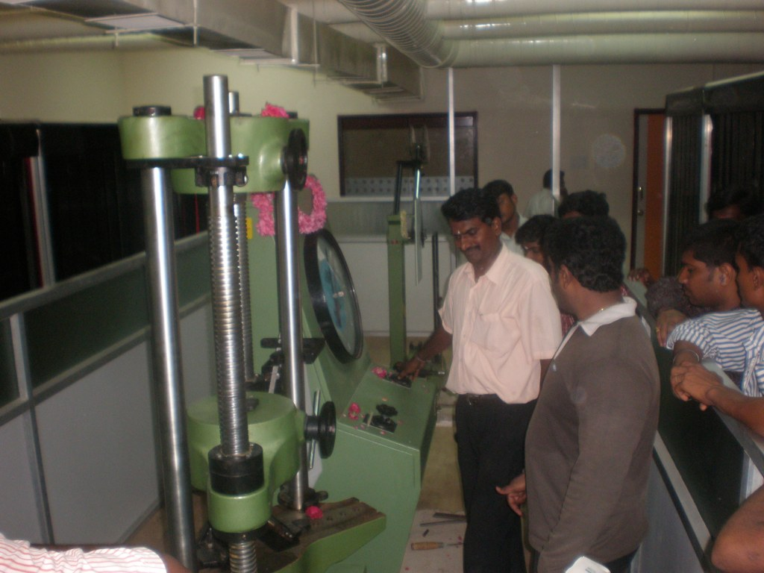
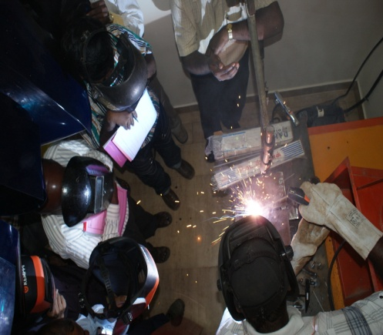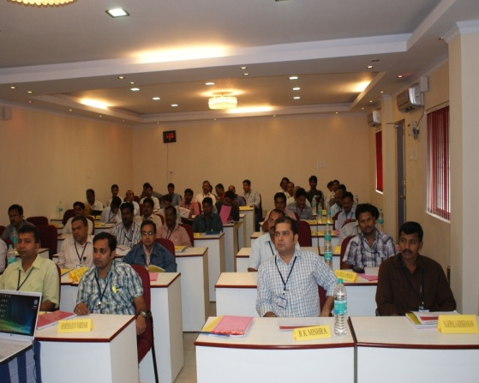


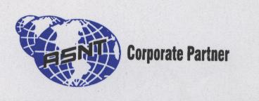
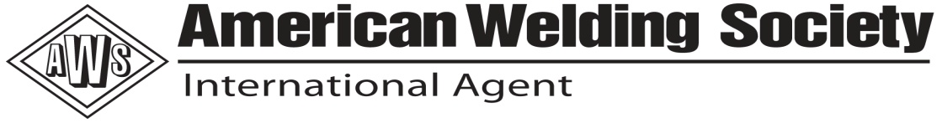

BETZ ENGINEERING & TECHNOLOGY ZONE
49-Vellalar Street, Adambakkam, Chennai -600 088, INDIA
Tel: +91 44 65364123/22780291/,Mob: 9551665682/9551665683
Email: rg_ganesan@yahoo.com, betzzone@vsnl.net

